Design Studio Management system

**DECLARATION**

I hereby declare that this Design Studio Management system project is my own work and has, to the best of my knowledge, not been submitted to any other institution of higher learning.

Student: ___________________ Registration Number: _________________

Signature: ............................................... Date: .....................................................

## Abstract

The purpose of the project entitled as “DESIGN STUDIO MANAGEMENT SYSTEM” is to computerize the Front Office Management of design studio, to develop software which is user friendly simple, fast, and cost – effective. It deals with the collection of designs provided by designers information, booking reservations advertising, etc. Traditionally, it was done manually. The main function of the system is register and store patient details and Designers details and retrieve these details as and when required, and also to manipulate these details meaningfully System input contains patient details, diagnosis details, while system output is to get these details on to the screen. The Design Studio Management System can be entered using a username and password. It is accessible either by an administrator or receptionist. Only they can add data into the database. The data can be retrieved easily. The data are well protected for personal use and makes the data processing very fast.

# 

Table of content

**DECLARATION** 2

Abstract 3

Problem statement and motivation 6

**OBJECTIVE** 7

modules…………………………………………………………………………………………………………………………………………7

requirement specifications…………………………………………………………………………………………………………….…8

system design ………………………………………………………………………………………………………………………………..13

system implementation …………………………………………………………………………………………………………………17

system testing and conclusion ………………………………………………………………………………………………………27

references……………………………………………………………………………………………………………………………………….29

**Chapter 1**

**Introduction:**

The project DESIGN STUDIO MANAGEMENT SYSTEM includes registration of designers, designs, storing their details into the system booking appointment. The software has the facility to give a unique id for every order, booking and stores the details of every designer and designs automatically. User can view availability of a designs and the details of designs using the id.

The Design Studio Management System can be entered using a username and password. It is accessible either by an administrator or user. An admin can add data into the database. The data can be retrieved easily. The interface is very user-friendly. The data are well protected for personal use and makes the data processing very fast.

Design Studio Management System is powerful, flexible, and easy to use and is designed and developed to deliver real conceivable benefits to hospitals.

Design Studio Management System is designed for multispecialty designs, to cover a wide range of Design administration and management processes. It is an integrated end-to-end

Design Studio Management System is a software product suite designed to improve the quality and management of designs and activity-based costing. Design Studio Management System enables you to develop your organization and improve its effectiveness and quality of work. Managing the key processes efficiently is critical to the success that helps you manage your processes

## Problem statement and motivation

Part of what makes project management in design so challenging is that there’s a lot of collaboration happening on each and every project.

Not only is your internal team of designers working together and leaning on each other’s unique skills and expertise, but you also need to interact with your clients for direction, revisions, and approvals.

But despite these hurdles, figuring out how to facilitate successful internal and external collaboration is important, especially when you consider that one survey found that 86% of respondents blame lack of collaboration or ineffective communication for workplace failures.

### **OBJECTIVE**

* Our software will perform and fulfill all the tasks that any customer would desire.
* Our software system mainly deals with customers booking and viewing designs and adverts
* The various features added to the project provide all the functions to make the task easy to perform.

**MODULES**

The entire project mainly consists of 2 modules, which are

* Admin module
* User module

**Admin module**

* manage designers
* watch appointment of Designers
* changing the appointment status
* adding new designs and designers

**1.3.2 user module**

This part features.

* viewing designs
* Viewing designers schedule
* Viewing adverts
* Placing appointment etc

**CHAPTER 2**

**REQUIREMENT SPECIFICATION**

**2.1 INTRODUCTION**

To be used efficiently, all computer software needs certain hardware components or the other software resources to be present on a computer. These pre-requisites are known as(computer) system requirements and are often used as a guideline as opposed to an absolute rule. Most software defines two sets of system requirements: minimum and recommended. With increasing demand for higher processing power and resources in newer versions of software, system requirements tend to increase over time. Industry analysts suggest that this trend plays a bigger part in driving upgrades to existing computer systems than technological advancements.

**Analysis & Design**

In order to have ensured a proper implementation that fulfills the needs for an

installation package, appropriate preliminary planning took place. Initially,

the project team carefully studied the source code of the system. It was important to have

a full understanding of how it worked, particularly as it relates to the setup routines.

Once the program was understood, a coherent plan of action was assembled.

In this project we used the following software’s;

* visual studio
* MySQL server for database administration
* web browser

intergrading languages;

front end:

* HTML/CSS
* Java script

Back end;

Xampp server for php programming language to develop models

**HTML**

HTML or Hypertext Markup Language is the standard [markup language](http://en.wikipedia.org/wiki/Markup_language) used to create [web pages](http://en.wikipedia.org/wiki/Web_page).

HTML is written in the form of [HTML elements](http://en.wikipedia.org/wiki/HTML_element) consisting of *tags* enclosed in [angle brackets](http://en.wikipedia.org/wiki/Angle_brackets) (like <html>). HTML tags most commonly come in pairs like <h1> and </h1>, although some tags represent *empty elements* and so are unpaired, for example <img>. The first tag in a pair is the *start tag*, and the second tag is the *end tag* (they are also called *opening tags* and *closing tags*). Though not always necessary, it is best practice to append a slash to tags which are not paired with a closing tag.

The purpose of a [web browser](http://en.wikipedia.org/wiki/Web_browser) is to read HTML documents and compose them into visible or audible web pages. The browser does not display the HTML tags, but uses the tags to interpret the content of the page. HTML describes the structure of a website [semantically](http://en.wikipedia.org/wiki/Semantic) along with cues for presentation, making it a [markup language](http://en.wikipedia.org/wiki/Markup_language) rather than a [programming language](http://en.wikipedia.org/wiki/Programming_language).

HTML elements form the building blocks of all [websites](http://en.wikipedia.org/wiki/Website). HTML allows [images and objects](http://en.wikipedia.org/wiki/Img_(HTML_element)) to be embedded and can be used to create [interactive forms](http://en.wikipedia.org/wiki/Fieldset). It provides a means to create [structured documents](http://en.wikipedia.org/wiki/Structured_document) by denoting structural [semantics](http://en.wikipedia.org/wiki/Semantic) for text such as headings, paragraphs, lists, [links](http://en.wikipedia.org/wiki/Hyperlink), quotes and other items. It can embed [scripts](http://en.wikipedia.org/wiki/Scripting_language) written in languages such as [JavaScript](http://en.wikipedia.org/wiki/JavaScript) which affect the behaviours of HTML web pages.

**CASCADING STYLE SHEETS (CSS)**

It is a style sheet language used for describing the look and formatting of a document written in a markup language. While most often used to style web pages and interfaces written in HTML, the language can be applied to any kind of XML document. CSS is a cornerstone specification of the web and almost all web pages use CSS style sheets to describe their presentation.

In this case we have used CSS for styling our html pages that are written in php

**MySQL**

MySQL is a database system used on the web it runs on a server. MySQL is ideal for both small and large applications. It is very fast, reliable, and easy to use. It supports standard SQL. MySQL can be compiled on a number of platforms.

The data in MySQL is stored in tables. A table is a collection of related data, and it consists of columns and rows. Databases are useful when storing information categorically

**JAVASCRIPT**

JavaScript is the scripting language of the Web. All modern HTML pages are using JavaScript. A scripting language is a lightweight programming language. JavaScript code can be inserted into any HTML page, and it can be executed by all types of web browsers. JavaScript is easy to learn.

**PHP**

WHAT IS PHP?

* PHP is an acronym for "PHP Hypertext Pre-processor"
* PHP is a widely-used, open-source scripting language
* PHP scripts are executed on the server
* PHP costs nothing, it is free to download and use

WHAT IS PHP FILE?

* PHP files can contain text, HTML, CSS, JavaScript, and PHP code
* PHP code are executed on the server, and the result is returned to the browser as plain HTML
* PHP files have extension ".php"

**CHAPTER 4**

SYSTEM DESIGN:

4.1.1 INTRODUCTION TO UML

UML Design

The Unified Modelling Language (UML) is a standard language for specifying, visualizing, constructing, and documenting the software system and its components. It is a graphical language, which provides a vocabulary and set of semantics and rules. The UML focuses on the conceptual and physical representation of the system.by this we include the database model that we used for our project.

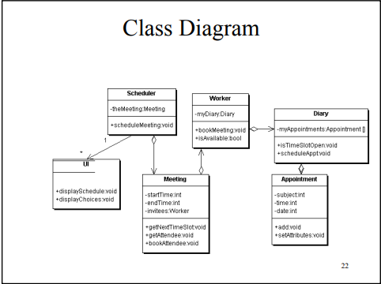

**VARIOUS TABELS TO MAINTAIN INFORMATION**

I have labelled my database “mosko” which includes 7 tables

* Appointments
* Appointment_list
* Designers_list
* Designers_schedule
* Designs
* Design specialities
* Users

1. ***Appointments*** ;

This table includes first name, last name, app_date, status. This table is called in a form that is filled by the user and the form is verified by the admin.

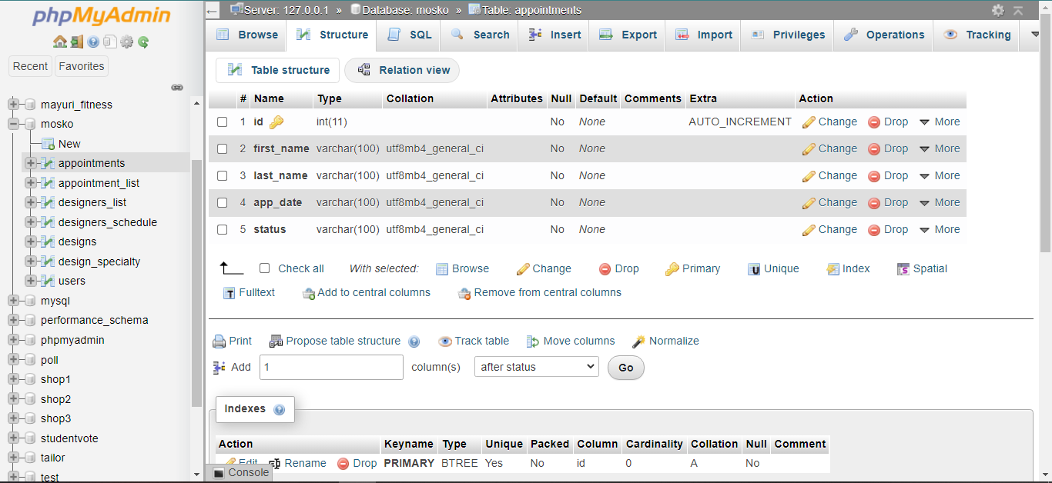

1. ***Appointment_list***

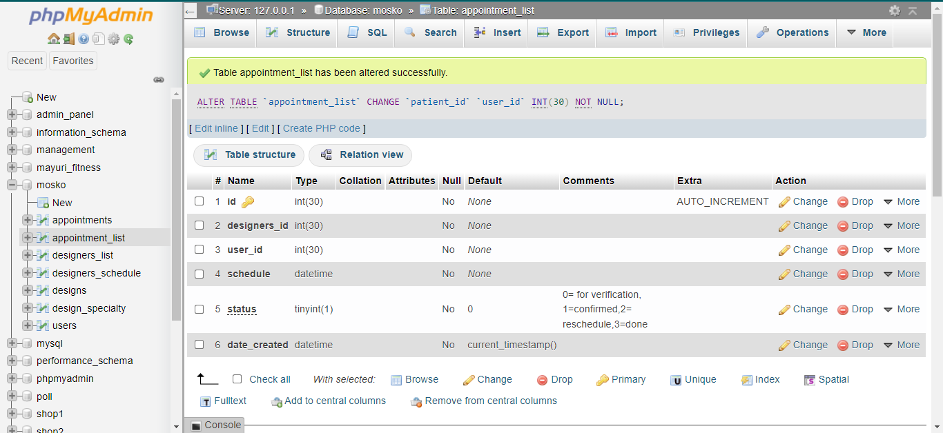

1. ***Designers_list***

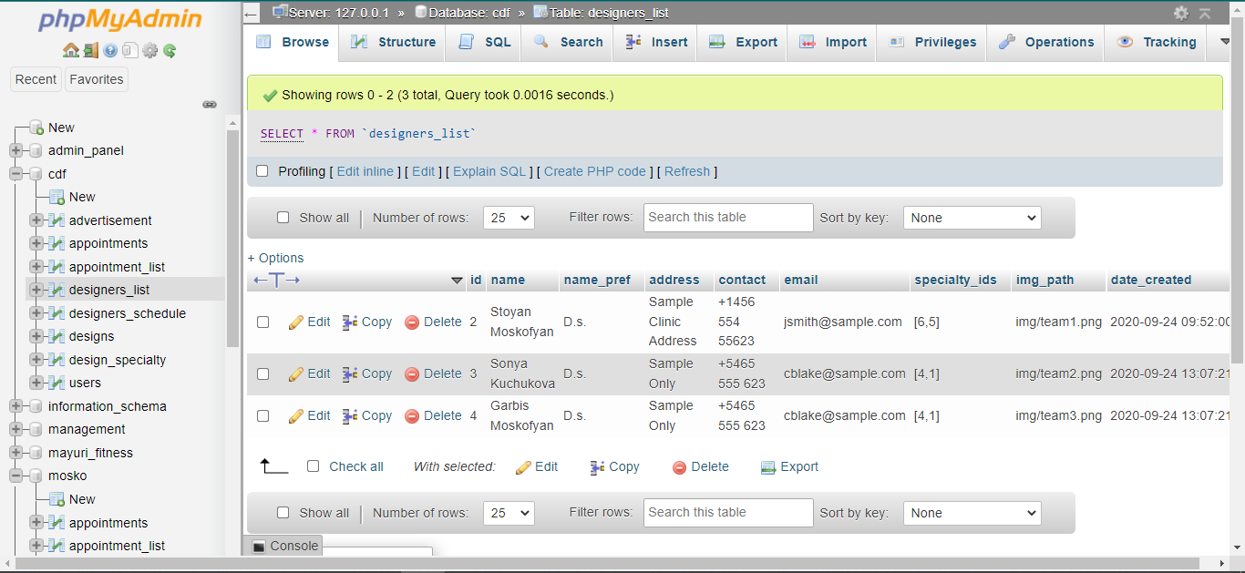

1. ***Designers_schedule***

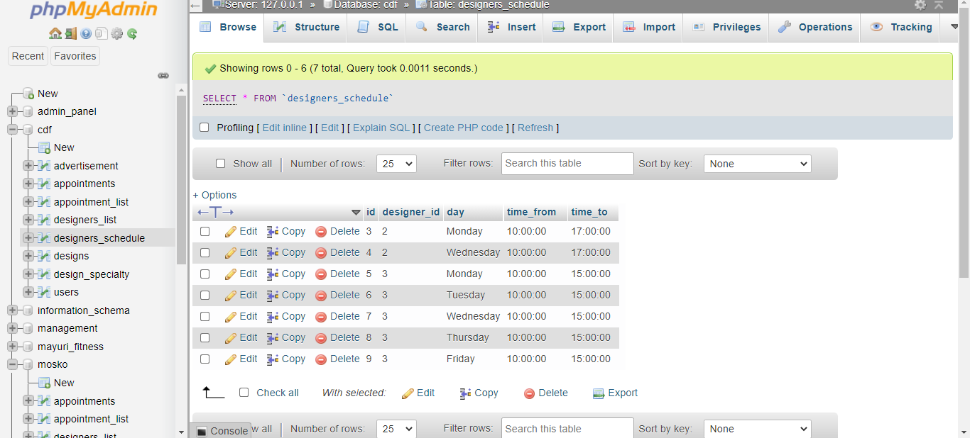

1. ***Designs***

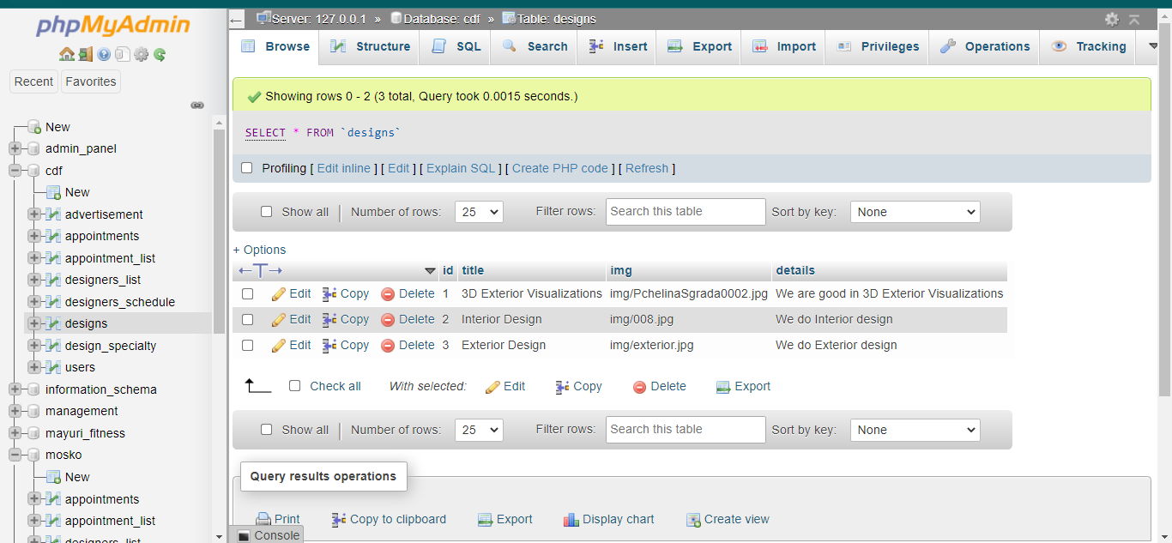

1. ***Design Speciality***



1. ***User***; this table store all the users information that is used in logging in. after the user is added by the admin or successful registering via register form the details are stored in this table.

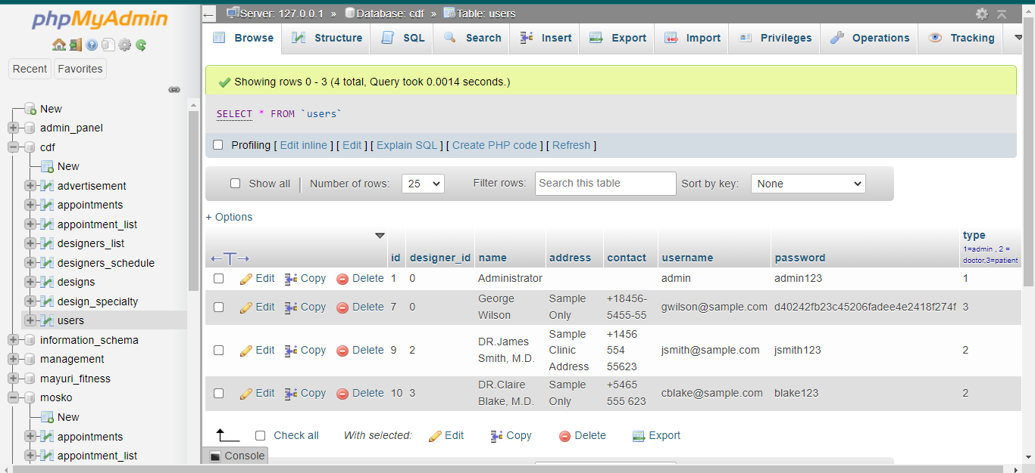

**CHAPTER 5**

**SYSTEM IMPLEMENTATION**

5.1 **Introduction**

The implementation stage involves careful planning, investigation of the existing system and its constraints on implementation, designing of methods to achieve changeover and evaluation of changeover methods. The project consist of several pages that are connected to operate together.

5.2 **Pages and sample screenshots.**

This project contain several pages;

1. Homepage
   * Architecture design
   * Advertising
   * Team
   * Philosophy
   * Connect
2. Booking
3. Register page
4. Login
5. Admin page

Homepage

This is the view page which on running, this page is accessible even without logging in. One can view schedules but cannot book an appointment.

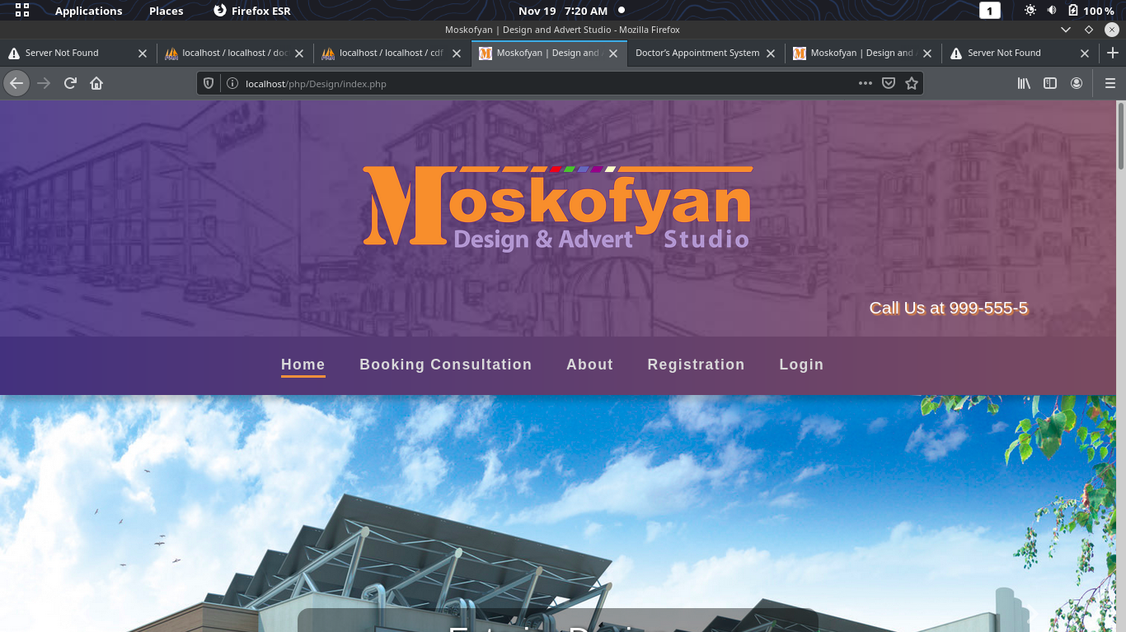

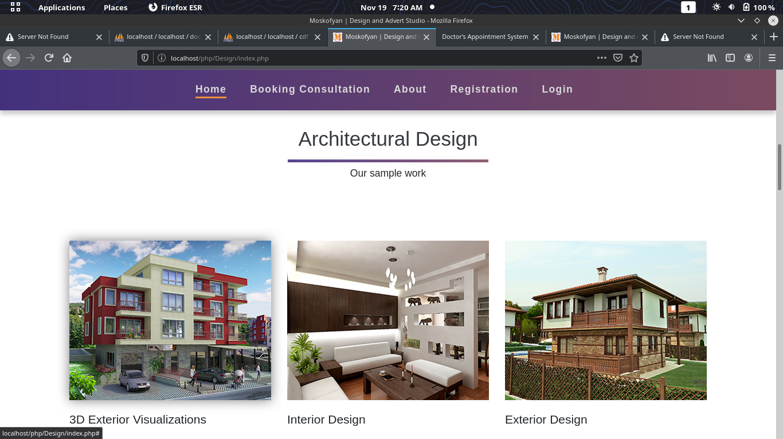

Architectural design which is viewed in the homepage.it displays different kind of designs and its picking the information from the database.

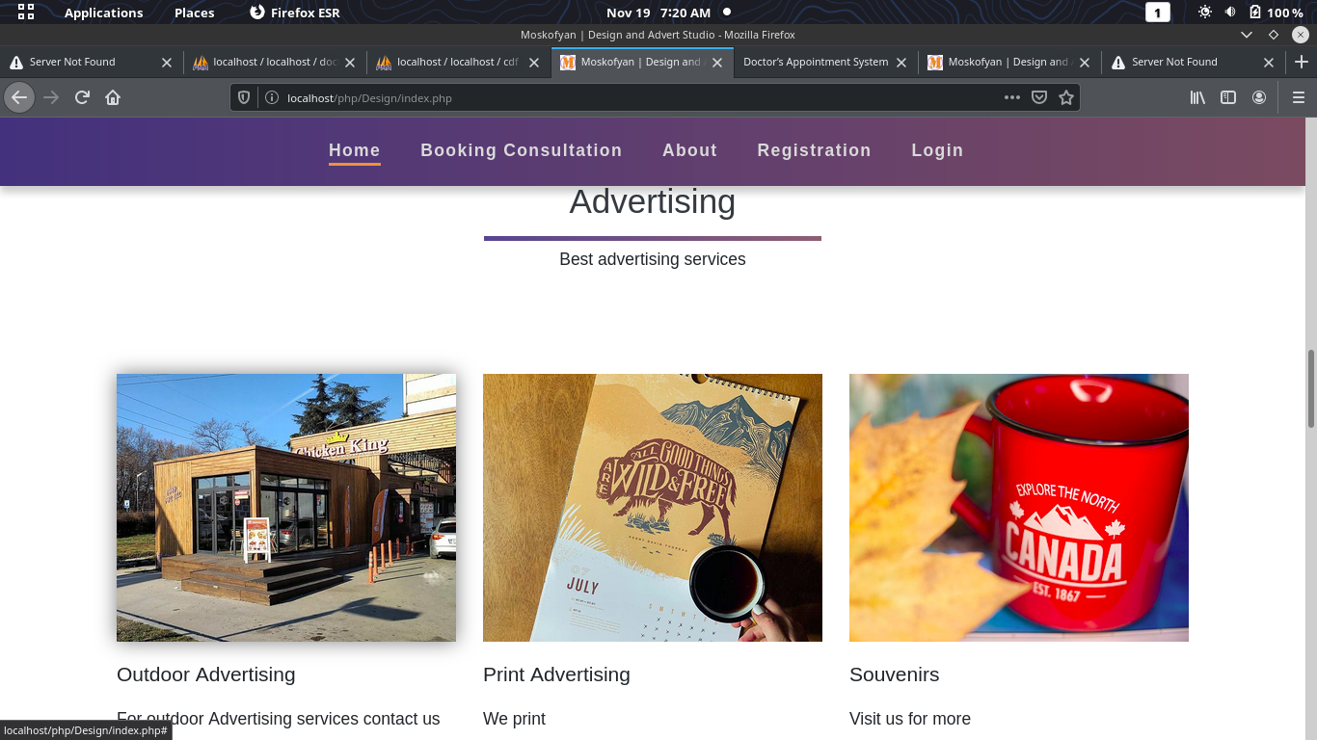

This part is also included in the home page.it is fetching data from the database and displaying the adverts in the homepage.

This Team part includes the list of designers registered in the system

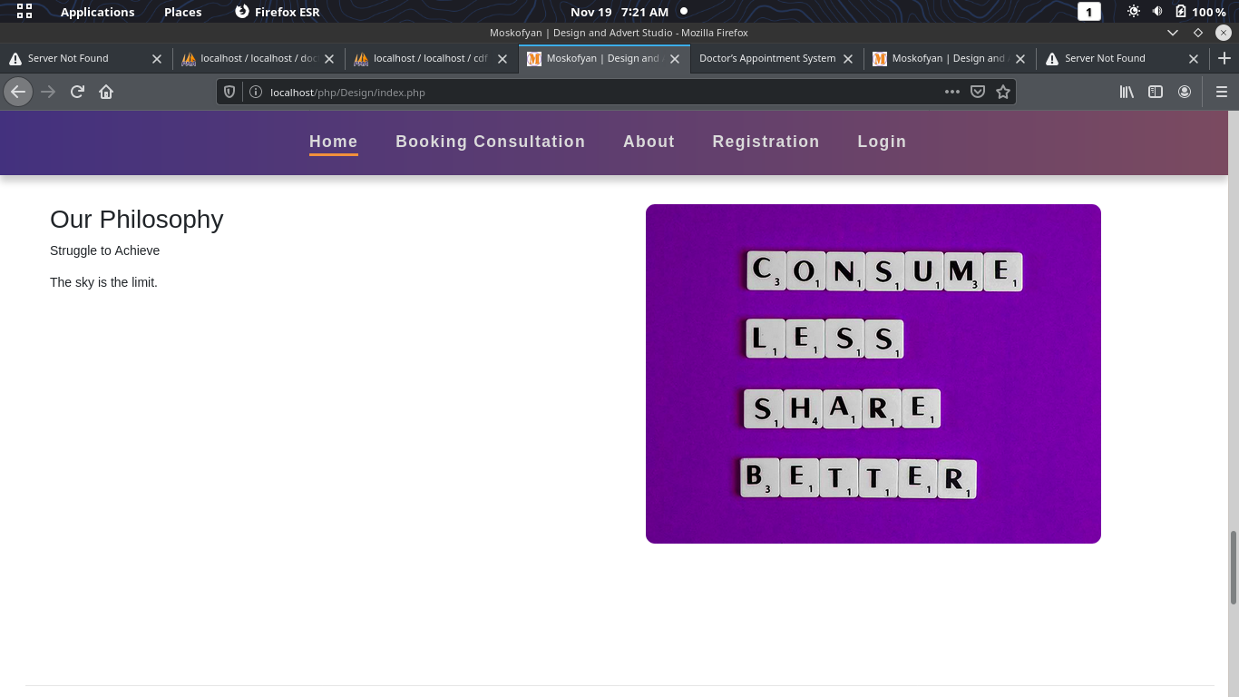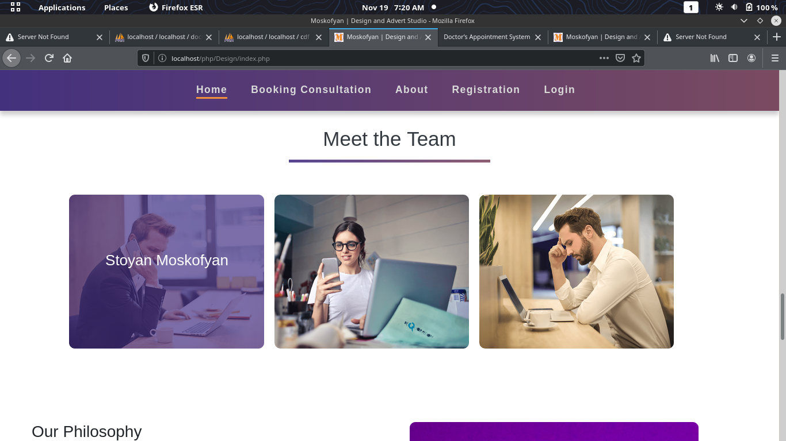



Register page

This page includes a form where a new user enter their details and the details are stored in the database and are also accessible by the admin.

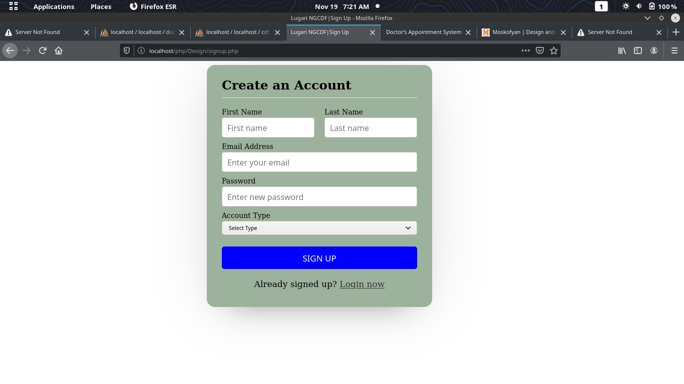

Login page;

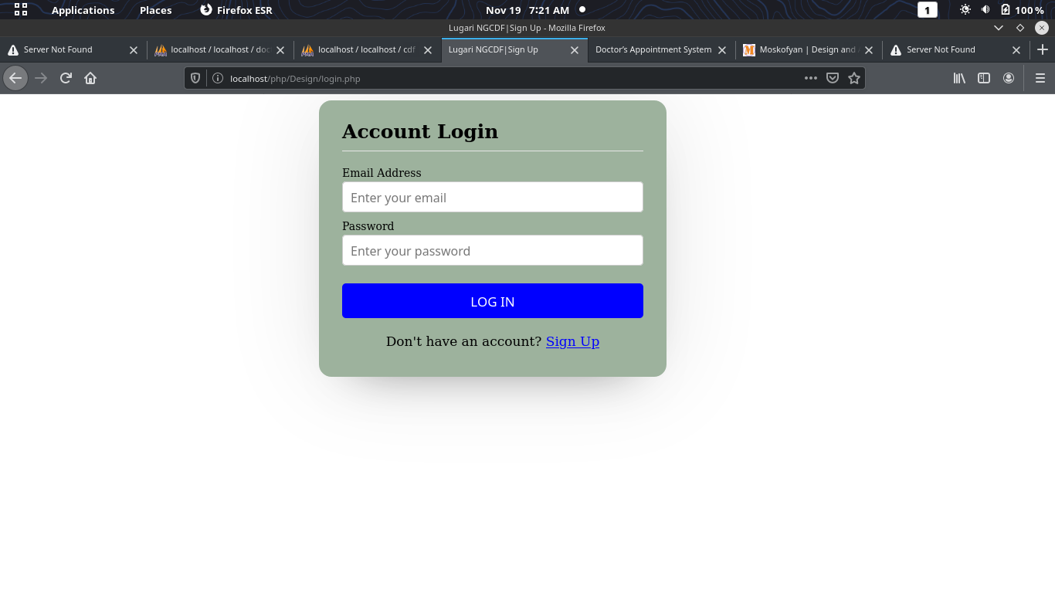

**Administrator**

This is the one in charge and with the full access and permissions for maintain the system.

* He/she can add, delete ,edit users.
* He/she can add, delete, edit Designers.
* He /she can view appointments and approve ,disapprove
* View edit designer specialty , edit and delete

***Administrator screenshots***

Admin dashboard.

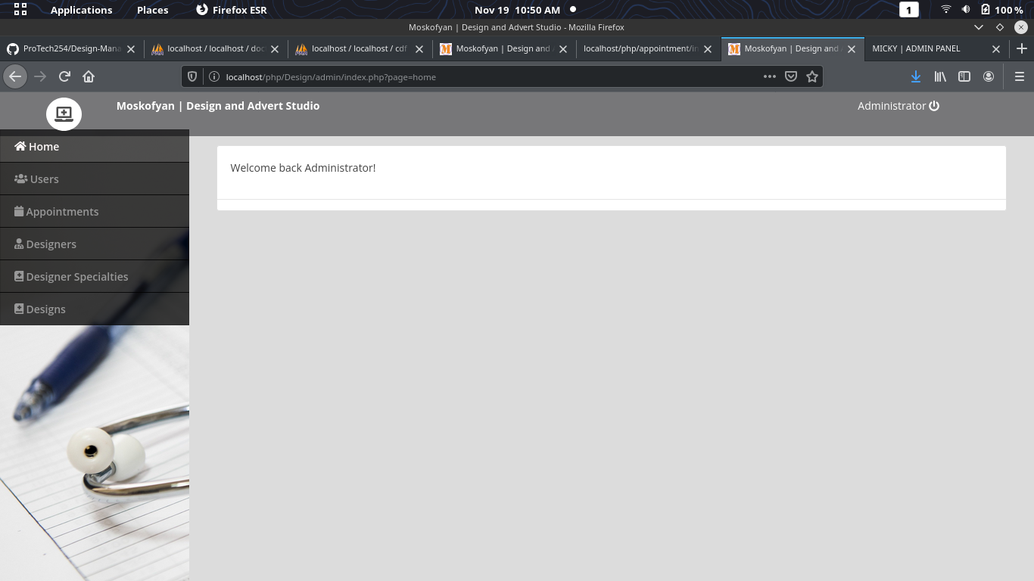

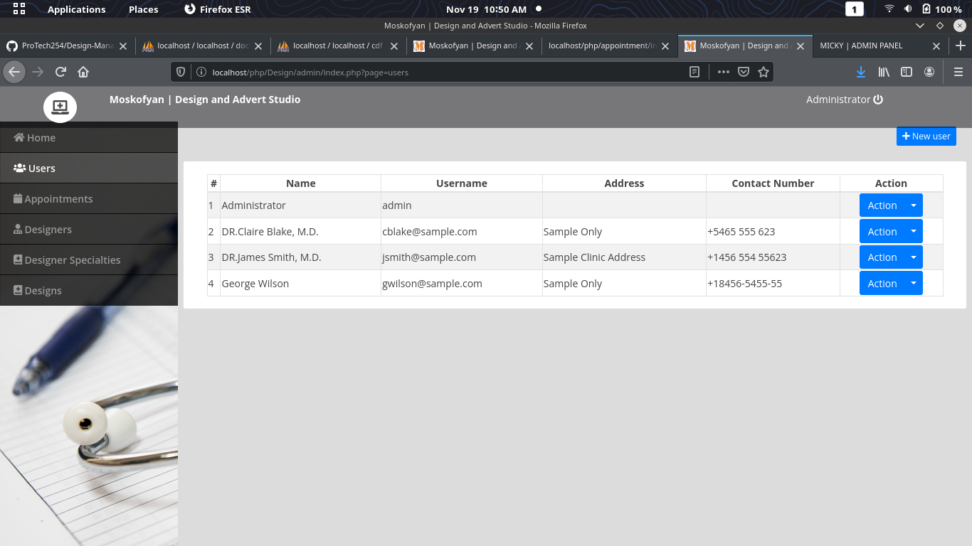

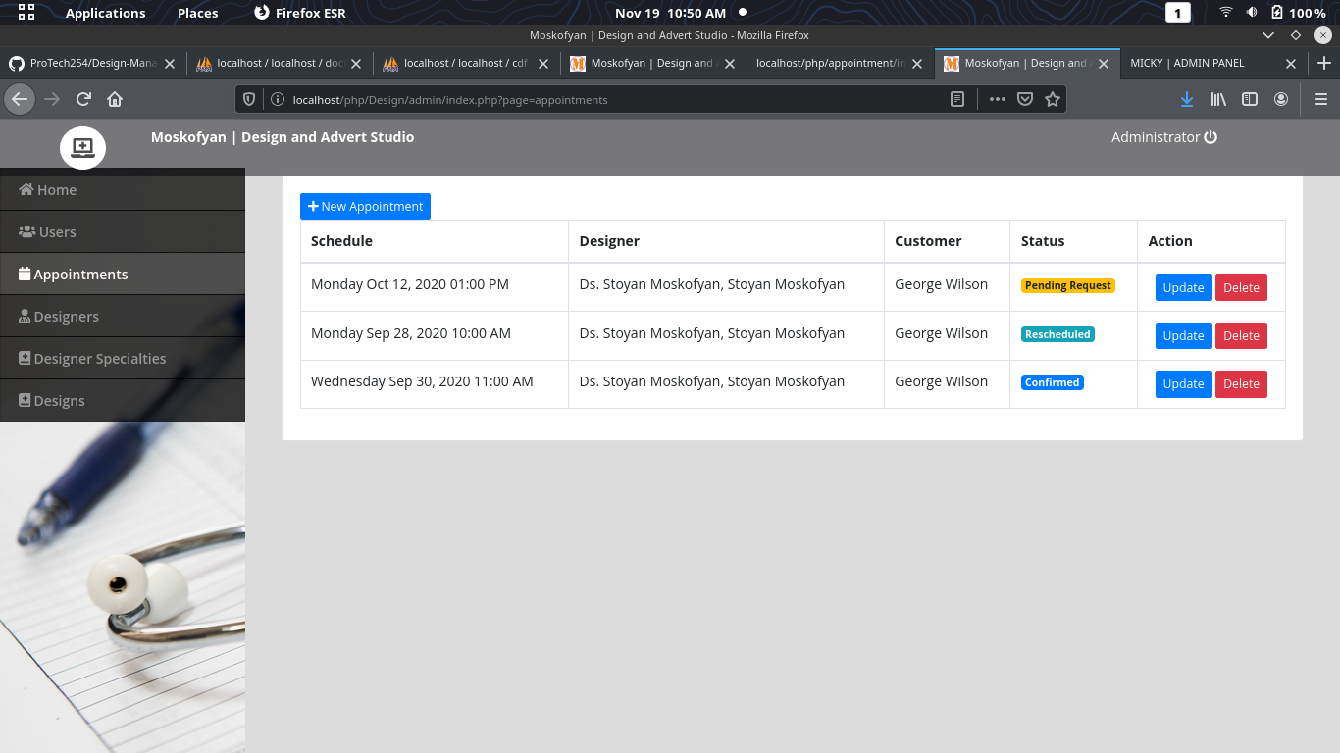

**Chapter 6**

**SYSTEM TESTING AND CONCLUSION**

SYSTEM TESTING

The aim of the system testing process was to determine all defects in our project. The program was subjected to a set of test inputs and various observations were made and based on these observations it will be decided whether the program behaves as expected or not. We installed the system on a new machine .

How to run the system

1. Open my SQL server. start Apache and my SQL module. click admin on MySQL and it will direct you to default browser.

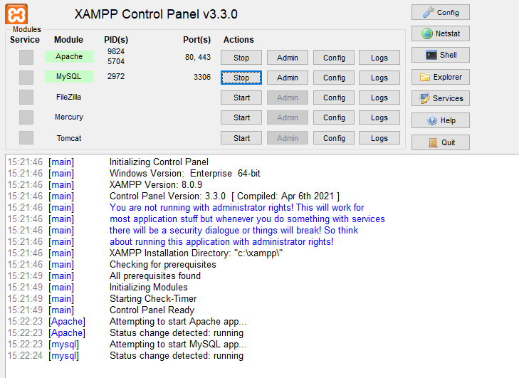

1. Create a new database and name it “cdf” .then import the sql file that is in the database folder in the project directory.
2. Move the folder containing the project files to htdocs inside Xampp folder.
3. To your browser run localhost/the folder name then enter.
4. On successful connection it will direct open the homepage and from there interact starts.

**CONCLUSION:**

Since we are entering storing information electronically in the” Design Studio management system”, data will be secured. Using this application, we can retrieve designers schedule and book appointments favourably, view designs with a single click. Thus, processing information will be faster. It guarantees accurate maintenance of designs and designer details and also the user details.

**CHAPTER 7**

**REFERENCES**

1. Software project management / Bob Hughes and Mike Cotterell, London [etc.]: McGraw-Hill, c2002, 3rd ed.
2. Information systems project management: methods, tools and techniques / John McManus and Trevor Wood-Harper, Harlow [etc.] : Prentice Hall, c2003
3. Subversion version control: using the Subversion version control system in development projects / William Nagel, Upper Saddle River (N.J.): Prentice Hall/PTR, c2005
4. Systems Analysis and Design Shelly Cashman Adamski Boston 1991 6. Software Engineering Roger S.Pressman UK, c2000, 5th ed